Multiple sequence alignment with the divide-and-conquer method
Jens Stoye
Gene, Volume: 211, Issue: 2, May 12, 1998, pp. GC45-GC56
- Introduction
- Divide-and-Conquer Alignment Algorithm
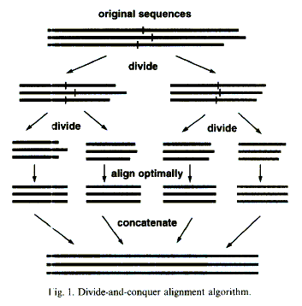
- Results
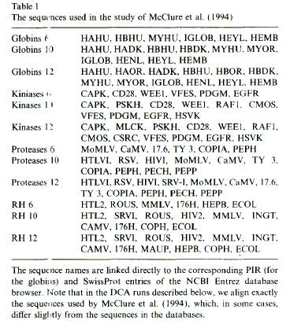

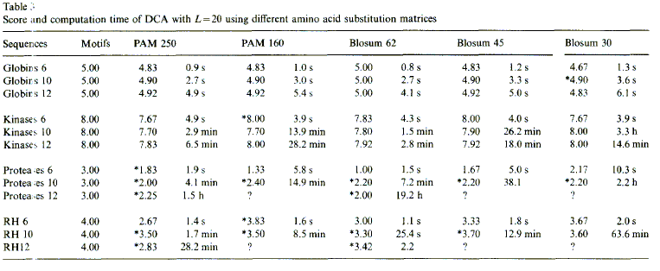

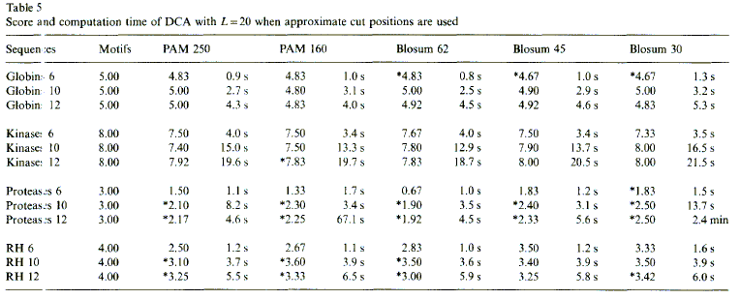
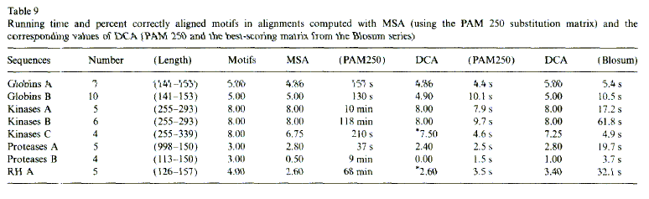
Created by : Ming-Cheng Lin
Date : May 17, 2000

